KAVI ADE
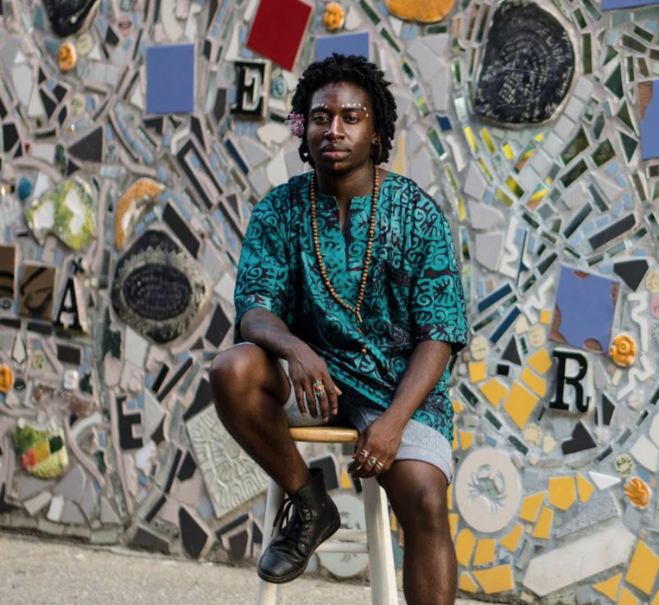
“Kavi is a nationally recognized spoken word artist...whose work confronts the many manifestations of violence perpetuated against the Black-trans-Queer body.”

“Through poetry they navigate despair, rage, and grief, but also joy, wonder, and becoming.”

QUEER CONFERENCE
MARCH 2ND
^{hamp.it/5cqgsc}

